Build an Agentic Workflow — Lesson Plan
Classification: UNCLASSIFIED

1. Administrative and metadata

1.1 Lesson title
Build an Agentic Workflow

1.2 Module length
60 minutes (1 hours)
Schedule slot is 60 minutes. Content-guide ~60 minutes plus a transition matches that slot.

1.3 Terminal and enabling learning objectives
- TLO-5: At the end of the Counterstrike Operator Course, students will be able to use local inference and agentic workflows to support hunting and planning, and counter adversary agentic systems.
- ELO-83: Describe agentic workflow architecture (planner, tools, retrieval) in a mission context.

1.4 Prerequisites
- B04.M23: Partner Handoff Package

2. Personnel, range, and environment

2.1 Instructor and cadre
- 1 × instructor (required)
- 0 × range_engineer (not_applicable: Lecture Module; no range engineer required)
- 0 × auditor (not_applicable: Not used by this course)
- 0 × oversight_officer (not_applicable: Not used by this course)

2.2 Materials and resources
Instructor resources and pre-class preparation
- Classroom projector and screen; whiteboard for the opening contract
- Parent or sibling briefs listed in this Module folder
- Live tabs and references already named in this file's header
- Do not project flags, tokens, or answer-key values
Student resources and environment
- Student brief, student guide, or homework file in this Module folder when present
- Assigned range, workstation, or lab stack named in the student-facing file
- No extra kit beyond what the student-facing file already lists

3. Assessment and evaluation
ELO | Method | Related Module | Criteria
ELO-83 | in-class Q&A | — | In-class questions and check on learning in the content guide.

4. Instructional delivery

4.1 Opening, attention grabber, and motivator

Option 1 (Interactive / Whiteboard / Kinesthetic)
- Say: "This course shifts from manual effects operations into SI-assisted workflow construction. We are not treating the model as an authority. We are building a local workflow that reads evidence, applies a prompt, produces structured output, and tells us when a human needs to review the result."
- Do: Put the lesson contract on the board. Keep products from the prerequisite Module available.
- Ask (Q): What is the operational takeaway from this row?
- Expected Response (A): Facilitation. Restate the Say/Do in operator terms. Do not invent a new teaching point.

Option 2 (Digital Slide / Virtual / Slide Deck)
- Say: "This course shifts from manual effects operations into SI-assisted workflow construction. We are not treating the model as an authority. We are building a local workflow that reads evidence, applies a prompt, produces structured output, and tells us when a human needs to review the result."
- Show: The title slide and lesson objectives.
- Do: Confirm stations can open the required tool or file before the first teaching row.
- Ask (Q): What is the operational takeaway from this row?
- Expected Response (A): Facilitation. Restate the Say/Do in operator terms. Do not invent a new teaching point.

4.2 Side-by-side table of instruction
Visual / Slide Asset | Instructional Delivery & Instructor Notes
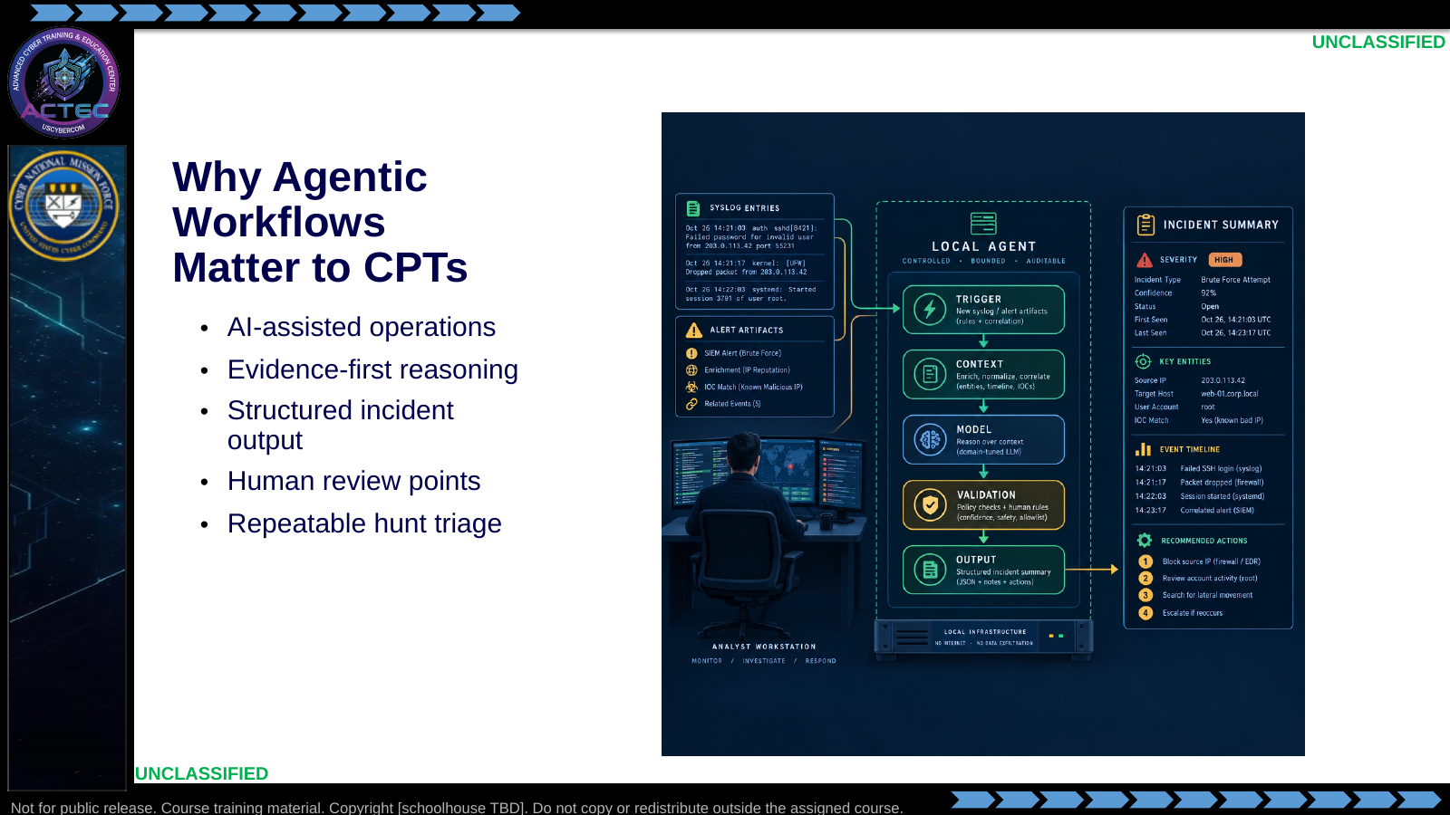  Slide 1: Why Agentic Workflows Matter to CPTs  Duration: 4 min | Say: "This course shifts from manual effects operations into SI-assisted workflow construction. We are not treating the model as an authority. We are building a local workflow that reads evidence, applies a prompt, produces structured output, and tells us when a human needs to review the result."  Show: Place this lesson in the Block arc: students first build the agentic triage pattern, then reinforce it, then extend the pattern with retrieval, tools, and adversary-agent considerations in later activities.  Do: Ask students to name one hunt task that is repetitive enough to automate but still risky enough to require human review. Capture two examples for reuse during the lecture.  Ask (Q): What is the operational takeaway from this row?  Expected Response (A): Facilitation. Restate the Say/Do in operator terms. Do not invent a new teaching point.
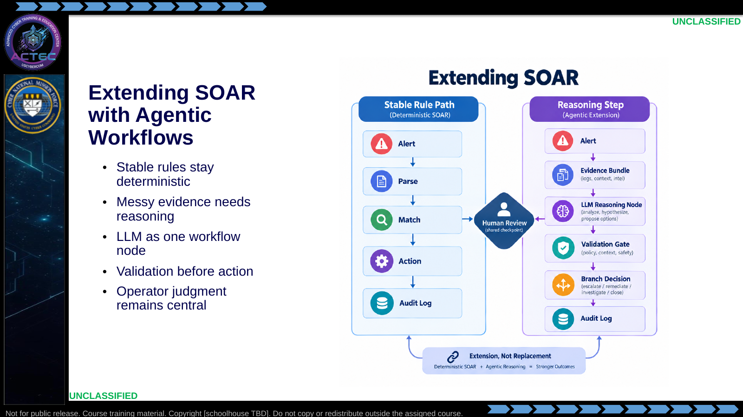  Slide 2: Extending SOAR with Agentic Workflows  Duration: 4 min | Say: "Do not hear this as 'SOAR is obsolete.' SOAR is excellent when the rule is clear and the data is stable. The agentic pattern belongs where the input is messy and the workflow needs a bounded reasoning step. The model does not replace orchestration; it becomes one controlled node inside it."  Show: Walk the deterministic path first, then the reasoning path, and point out where validation gates prevent model output from becoming unchecked action.  Do: Ask: "Which of these should stay deterministic: blocking a hash from a vetted feed, or summarizing an ambiguous process tree?" Have students explain the difference.  Ask (Q): Which of these should stay deterministic: blocking a hash from a vetted feed, or summarizing an ambiguous process tree?  Expected Response (A): Facilitation. Use the Say/Do already on this row; do not force a single keyed answer.
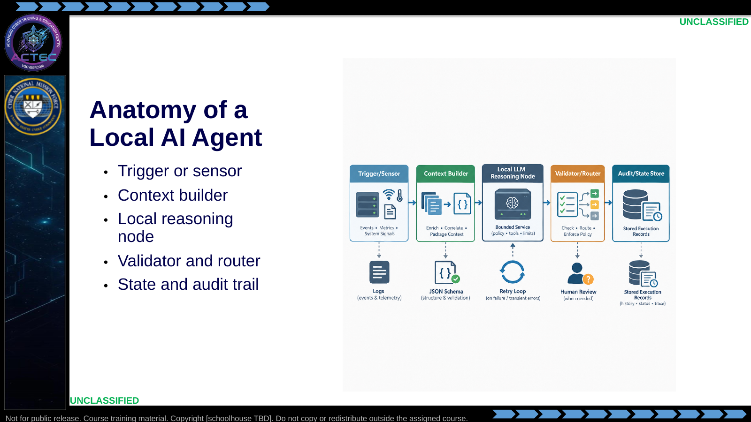  Slide 3: Anatomy of a Local SI Agent  Duration: 4 min | Say: "An agent is not just a model. The model is one reasoning node. The agent is the whole loop: what evidence enters, how context is built, what the model is allowed to produce, how the workflow validates it, and what record we keep afterward."  Show: Highlight the validator/router block. Tie it directly to the reinforcement lab failure modes: malformed JSON, API failures, and disagreement between branches.  Do: Have students repeat the operator test: "Can I explain what evidence went in, what prompt was used, what came out, and why the workflow took the branch it took?"  Ask (Q): What is the operational takeaway from this row?  Expected Response (A): Facilitation. Restate the Say/Do in operator terms. Do not invent a new teaching point.
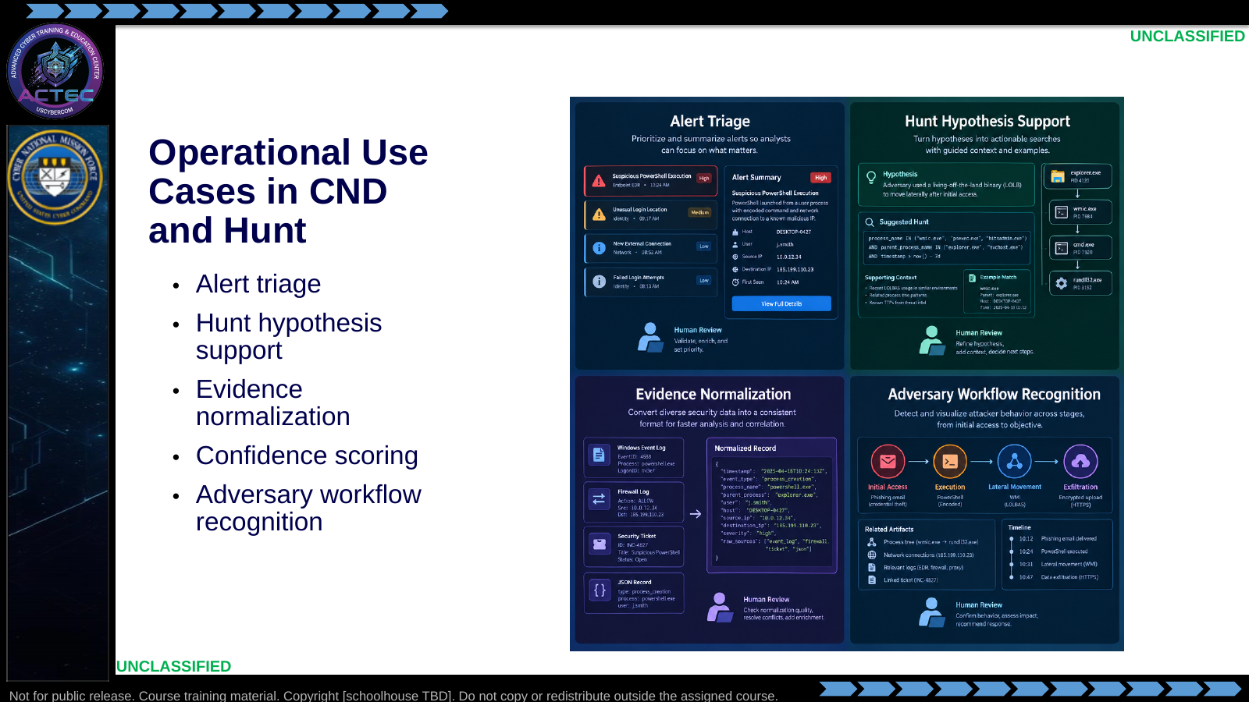  Slide 4: Operational Use Cases in CND and Hunt  Duration: 4 min | Say: "The common thread is not chat. The common thread is evidence transformation. We are asking the workflow to take messy evidence, make a bounded assessment, produce a machine-readable artifact, and mark uncertainty. That is useful for defenders, and it is also exactly why adversaries will use the same pattern."  Show: Connect each defensive example to a course build behavior: ingest, enrich, classify, validate, branch, and export.  Do: Ask: "Where is the human review point in each use case?" If students skip it, bring them back to confidence and operational risk.  Ask (Q): Where is the human review point in each use case?  Expected Response (A): Facilitation. Use the Say/Do already on this row; do not force a single keyed answer.
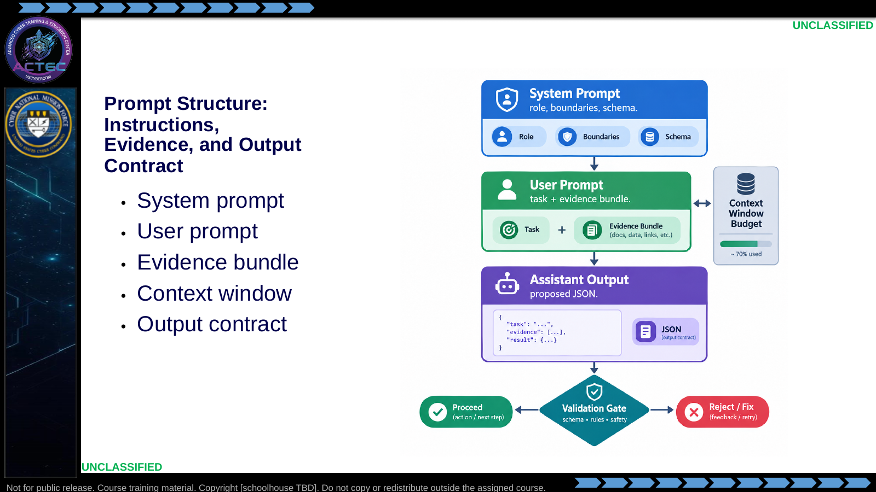  Slide 5: Prompt Structure: Instructions, Evidence, and Output Contract  Duration: 4 min | Say: "In a workflow, prompting is engineering. The system prompt defines stable behavior. The user prompt carries the current evidence. The output contract tells the model what shape downstream automation requires. If any one of those is vague, the workflow becomes brittle."  Show: The three-layer prompt structure, then point to the validation gate after the assistant output.  Do: Ask students what belongs in the system prompt versus the user prompt for a syslog triage workflow. Expected distinction: durable role/schema in system; current log and API results in user.  Ask (Q): What is the operational takeaway from this row?  Expected Response (A): Facilitation. Restate the Say/Do in operator terms. Do not invent a new teaching point.
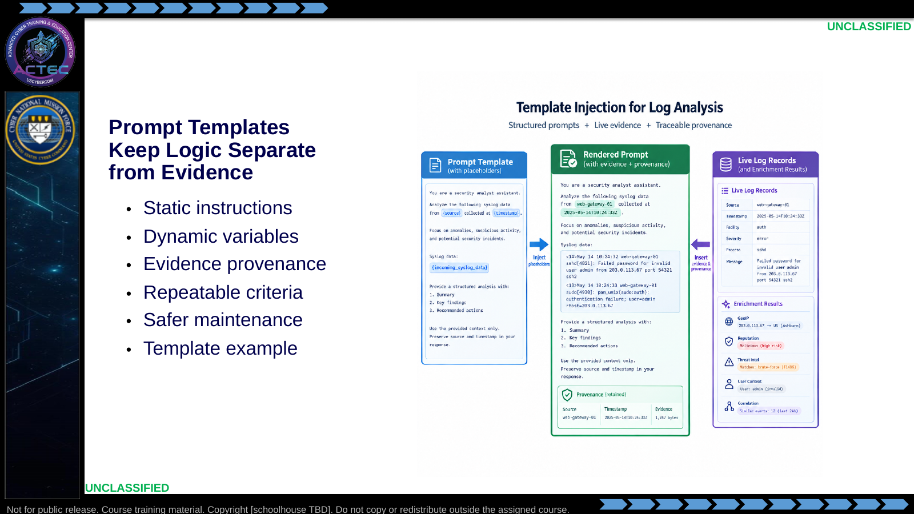  Slide 6: Prompt Templates Keep Logic Separate from Evidence  Duration: 4 min | Say: "We do not write a new prompt for every alert. We write a template. n8n injects the current log, source filename, timestamp, and enrichment results into known variables. That gives us repeatability and makes the output easier to debug."  Show: The example Analyze the following log for malicious activity: {{ incoming_syslog_data }} and add a second notional variable such as {{ threat_intel_result }}.  Do: Ask students which fields should be inserted automatically into every prompt for auditability: source artifact, timestamp, enrichment status, and workflow name.  Ask (Q): What is the operational takeaway from this row?  Expected Response (A): Facilitation. Restate the Say/Do in operator terms. Do not invent a new teaching point.
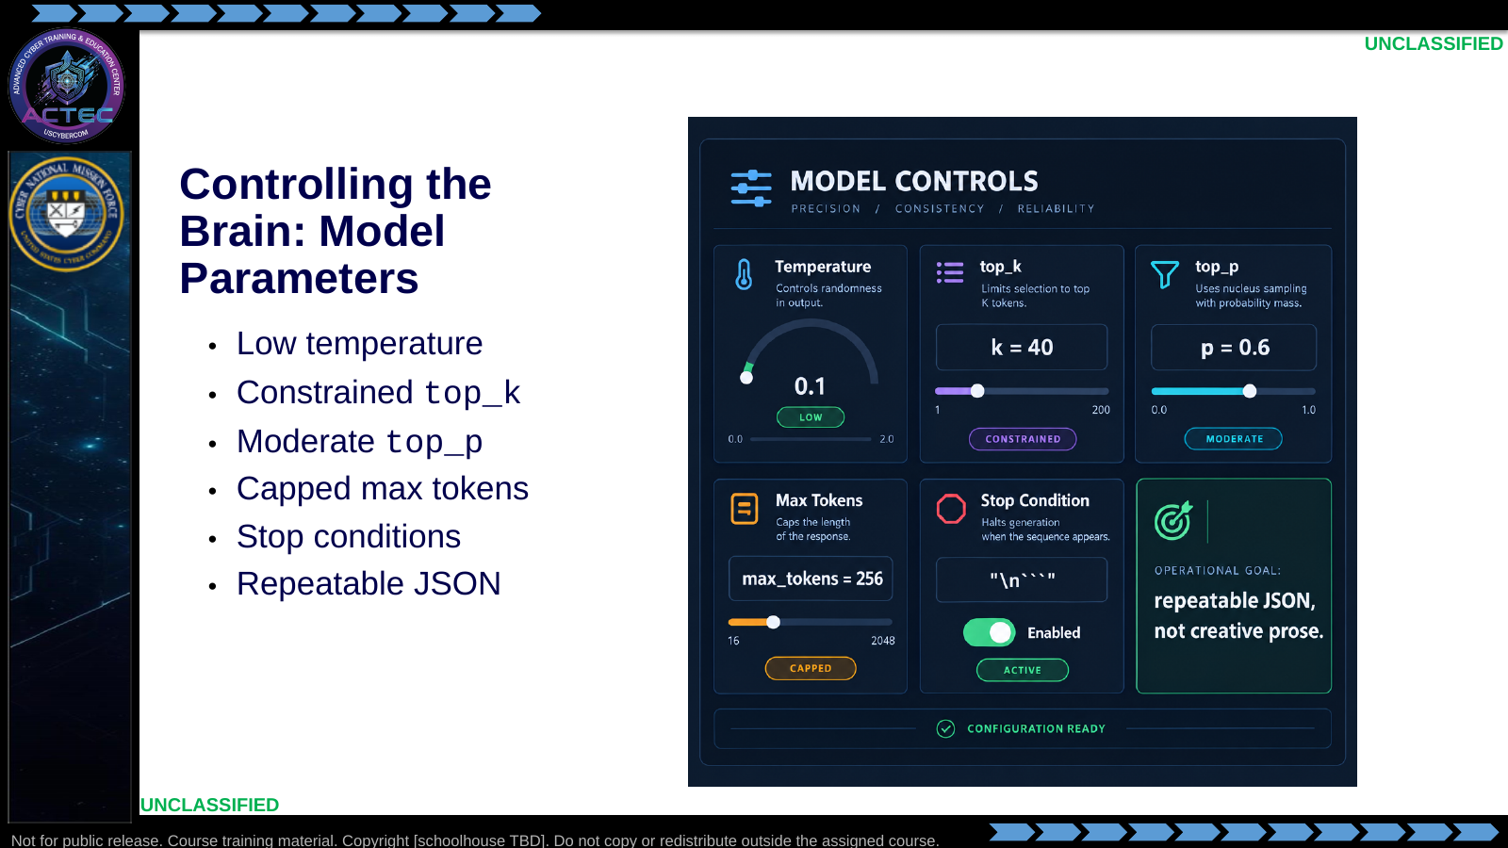  Slide 7: Controlling the Brain: Model Parameters  Duration: 4 min | Say: "LLMs predict tokens. Parameters influence how much variation the model is allowed to introduce. For a poem, variation is useful. For an incident workflow, variation can break a parser or inflate confidence. Today we tune for boring, repeatable, short outputs."  Show: The parameter controls and tie each to an operational failure mode: randomness, rambling, malformed output, or inconsistent confidence.  Do: Ask students why a low-temperature model can still be wrong. Drive toward: deterministic does not mean accurate; it only means repeatable.  Ask (Q): What is the operational takeaway from this row?  Expected Response (A): Facilitation. Restate the Say/Do in operator terms. Do not invent a new teaching point.
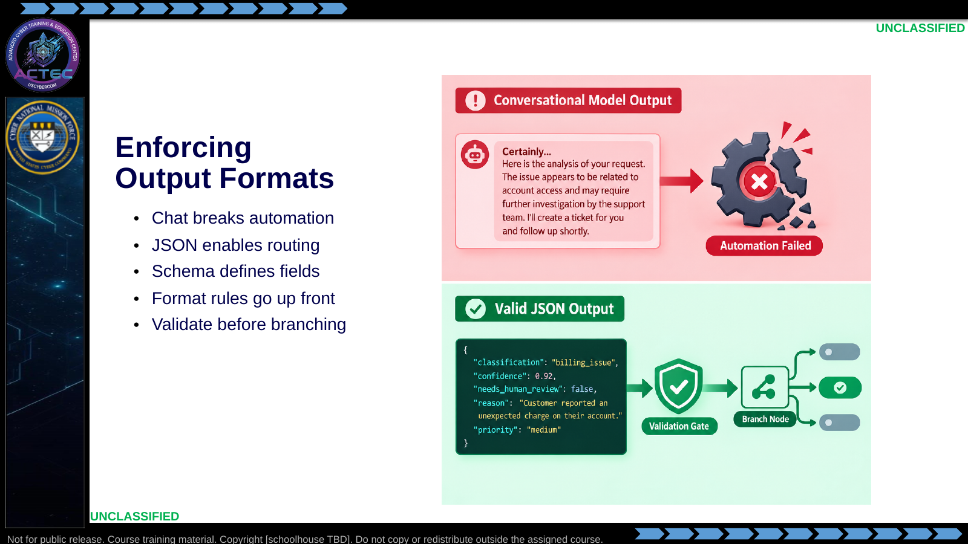  Slide 8: Enforcing Output Formats  Duration: 4 min | Say: "Downstream nodes do not read intent; they read fields. If the model gives a paragraph when the next node expects classification, confidence, and summary, the workflow is broken. Structured output is what turns language into an operational artifact."  Show: A small schema with classification, confidence, summary, intel_unavailable, and needs_human_review.  Do: Warn that local models can still drift from the schema. Validate and retry; do not skip the parser.  Ask (Q): What is the operational takeaway from this row?  Expected Response (A): Facilitation. Restate the Say/Do in operator terms. Do not invent a new teaching point.
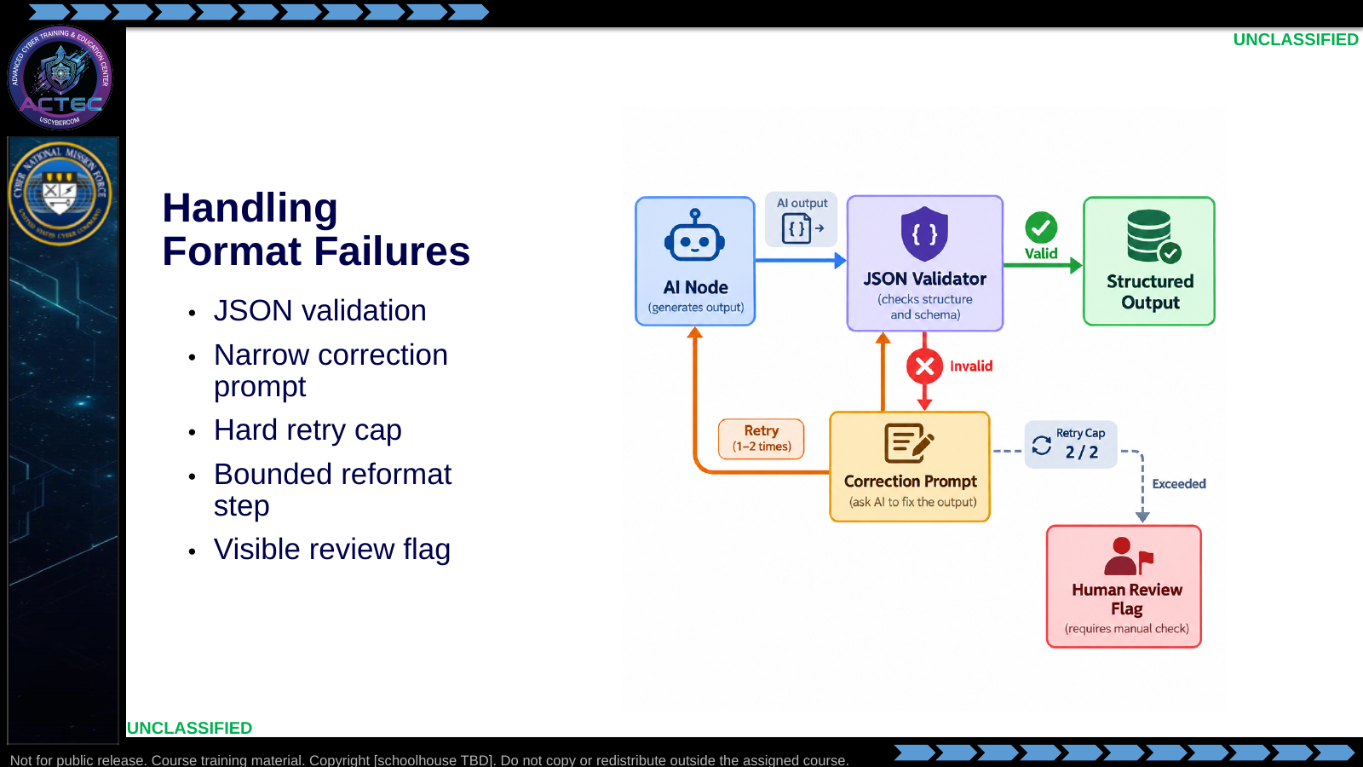  Slide 9: Handling Format Failures  Duration: 4 min | Say: "Even with good prompts, models sometimes produce invalid format. The professional answer is not hope; it is validation. Try once or twice with a narrower correction prompt, then fail gracefully with a review flag. A workflow that fails visibly is safer than one that invents a clean-looking answer."  Show: The validation loop and point at the retry cap.  Do: Tell students the hands-on workflow will deliberately stress these failure modes: broken JSON, enrichment failure, and conflicting branch evidence.  Ask (Q): What is the operational takeaway from this row?  Expected Response (A): Facilitation. Restate the Say/Do in operator terms. Do not invent a new teaching point.
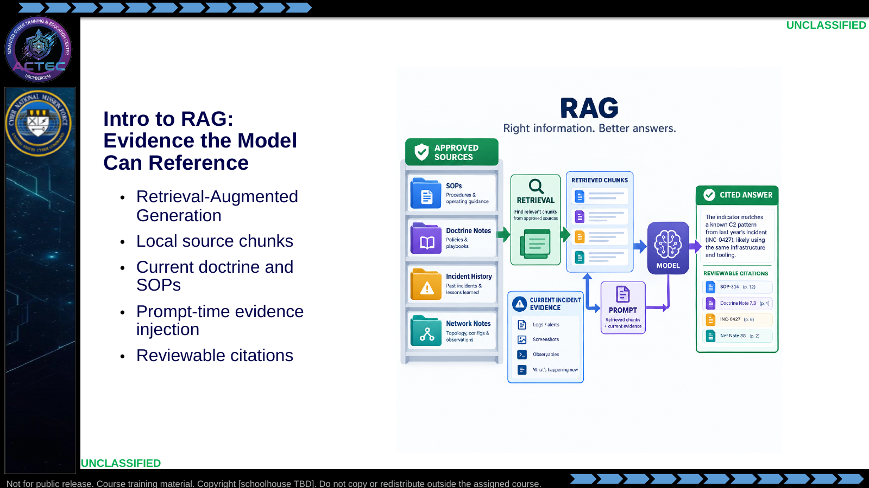  Slide 10: Intro to RAG: Evidence the Model Can Reference  Duration: 4 min | Say: "RAG is an open-book pattern. The model does not remember your local doctrine by default. The workflow searches the approved source material, retrieves the relevant chunks, and places those chunks into context. Now the model has evidence to reference."  Show: Contrast model weights, which are static for our purposes, with retrieved context, which can be updated as documents change.  Do: Keep this as a conceptual bridge. Students need the mental model here before the course turns retrieval into a primary build task.  Ask (Q): What is the operational takeaway from this row?  Expected Response (A): Facilitation. Restate the Say/Do in operator terms. Do not invent a new teaching point.
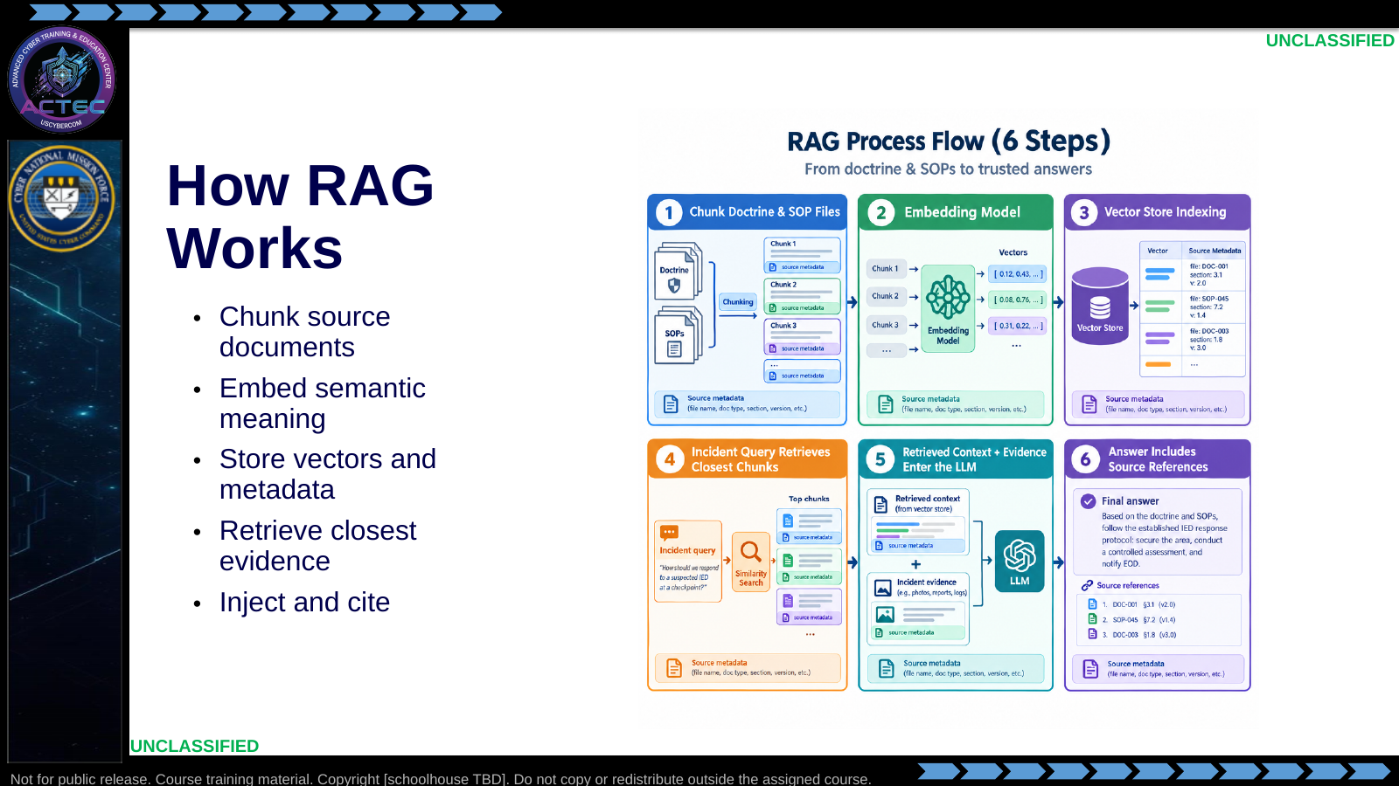  Slide 11: How RAG Works  Duration: 4 min | Say: "The search is semantic. If an incident mentions suspicious PowerShell behavior, retrieval can find doctrine or notes that discuss command interpreters, script execution, or T1059-style behavior even when the exact words differ. That is why embeddings matter to hunt operations."  Show: The full RAG flowchart, but keep the depth limited. Students only need the mental model today.  Do: Ask students what can go wrong if the corpus contains stale or poisoned information. Save the answer for the later adversary-agent discussion.  Ask (Q): What is the operational takeaway from this row?  Expected Response (A): Facilitation. Restate the Say/Do in operator terms. Do not invent a new teaching point.
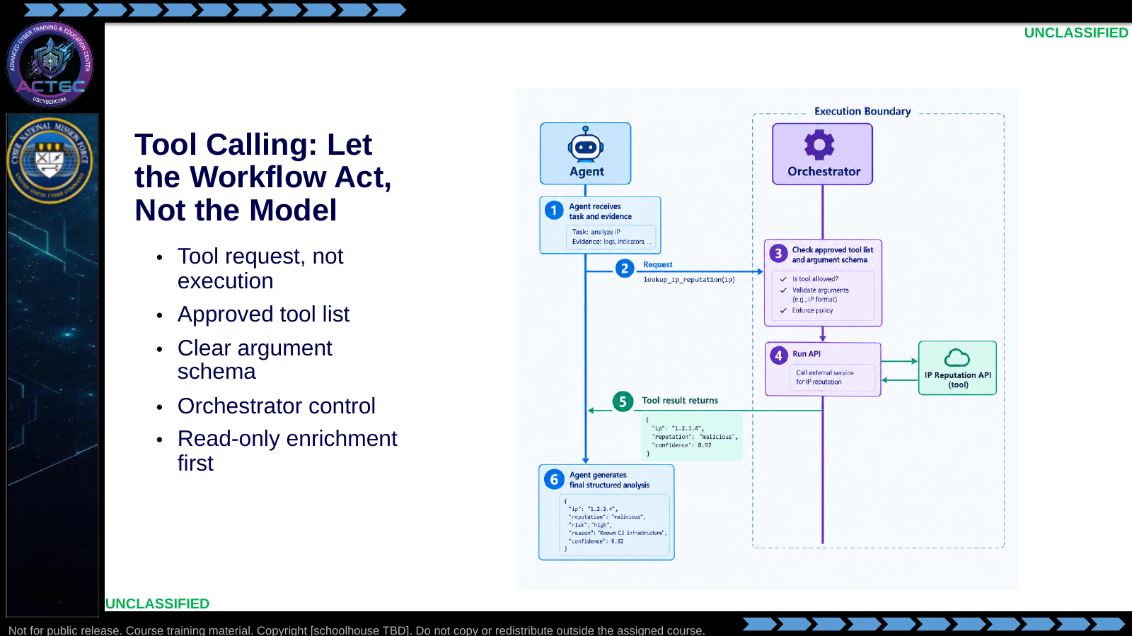  Slide 12: Tool Calling: Let the Workflow Act, Not the Model  Duration: 4 min | Say: "Tool calling is how an agent gets new information or asks the workflow to do something. The model does not execute the tool. It emits a structured request. n8n checks the request, runs the approved tool, and returns the result."  Show: The sequence diagram illustrating the pause in generation while the tool runs.  Do: Emphasize that the current build uses simple enrichment and parsing patterns. Later course work expands this into controlled tool use with explicit audit expectations.  Ask (Q): What is the operational takeaway from this row?  Expected Response (A): Facilitation. Restate the Say/Do in operator terms. Do not invent a new teaching point.
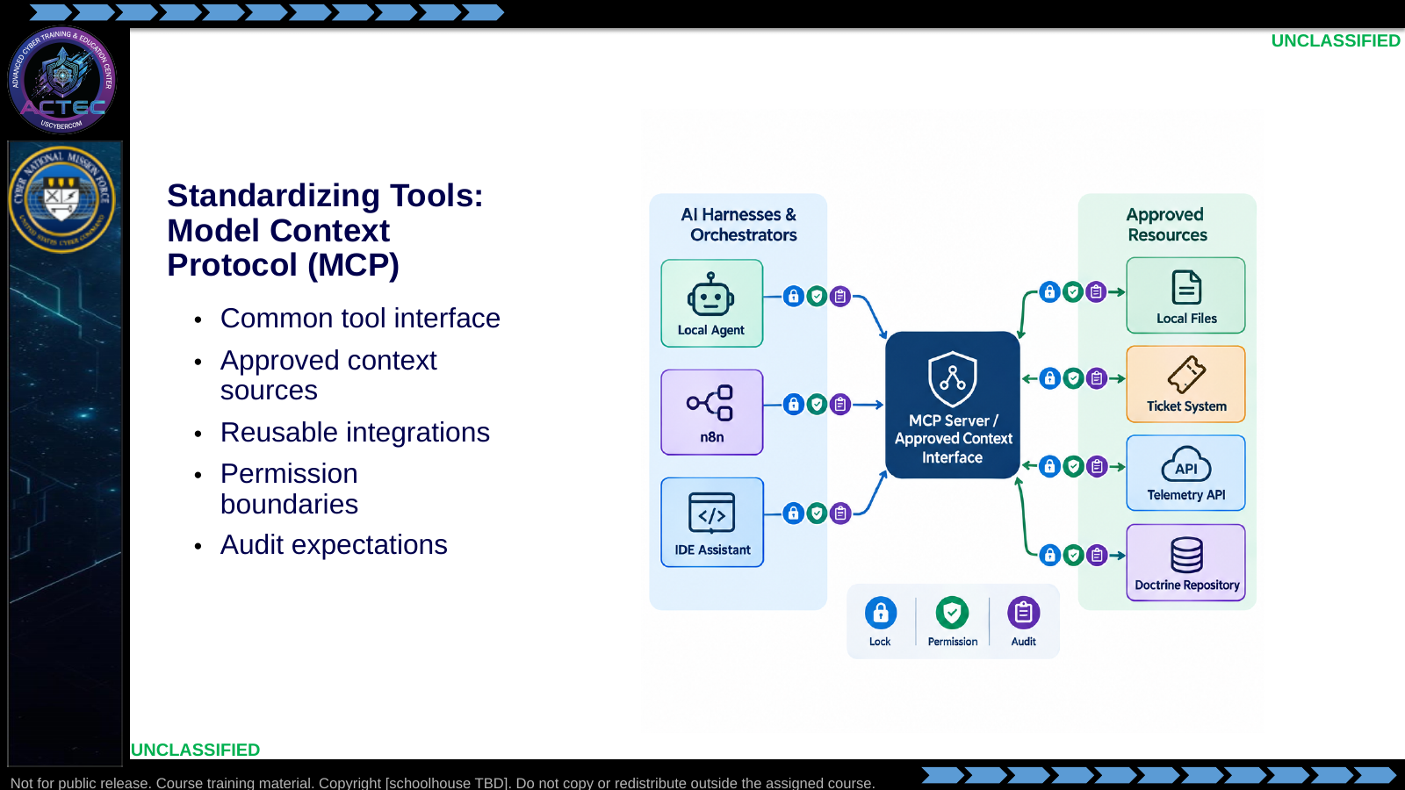  Slide 13: Standardizing Tools: Model Context Protocol (MCP)  Duration: 4 min | Say: "MCP is a standardization pattern. Instead of every agent building custom glue to every tool, an MCP server exposes approved capabilities in a common way. For an operational team, that matters because context access and tool access are part of the control surface."  Show: The hub-and-spoke diagram and point out that the center is not just convenience; it is where access can be described and constrained.  Do: Tell students they do not need to implement MCP today. They need to recognize why standards matter when agent workflows move from lab prototype to team service.  Ask (Q): What is the operational takeaway from this row?  Expected Response (A): Facilitation. Restate the Say/Do in operator terms. Do not invent a new teaching point.
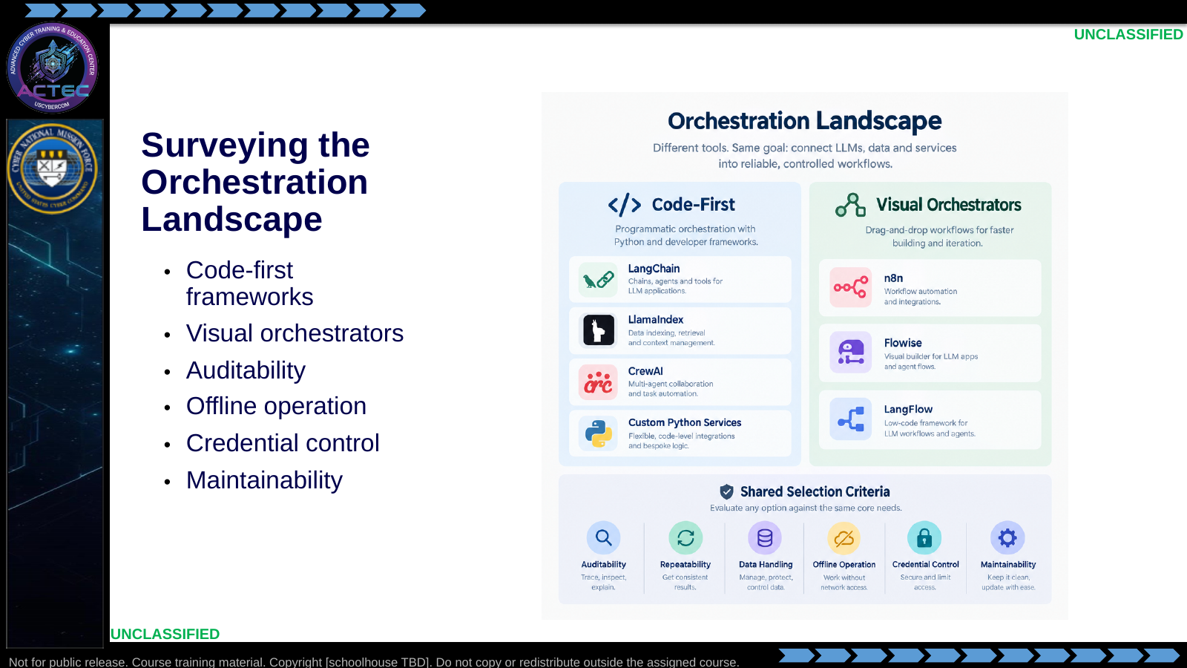  Slide 14: Surveying the Orchestration Landscape  Duration: 4 min | Say: "The right tool depends on the mission and the team. A software team may want code-first control. A CPT classroom needs visibility, repeatability, and fast debugging. n8n gives us a graph that an instructor can grade and a student can explain."  Show: A simple comparison: code-first for engineering depth; visual orchestration for workflow visibility and rapid operator iteration.  Do: Ask students what they would need before approving either pattern in a real environment: logging, credential handling, review, backups, and failure behavior.  Ask (Q): What is the operational takeaway from this row?  Expected Response (A): Facilitation. Restate the Say/Do in operator terms. Do not invent a new teaching point.
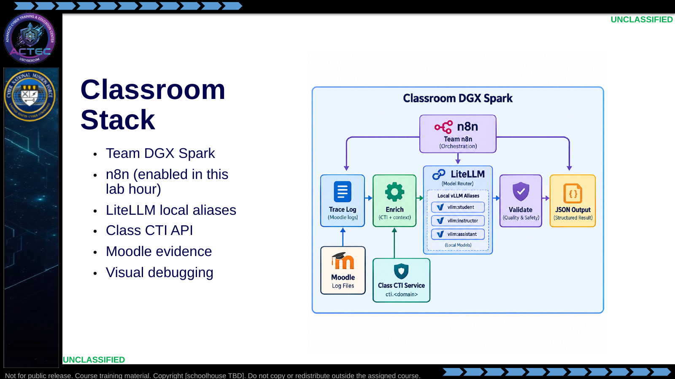  Slide 15: Classroom Stack  Duration: 4 min | Say: "Earlier stack setup left n8n out on purpose. This morning you add it to the team stack and create personal accounts. Inference goes through LiteLLM, never vLLM. CTI is a class service, not something you stand up per team."  Show: Trace syslog from Moodle into n8n, CTI lookup, secondary then primary model, JSON out.  Do: Have students name which component owns orchestration, inference, enrichment, and validation.  Ask (Q): What is the operational takeaway from this row?  Expected Response (A): Facilitation. Restate the Say/Do in operator terms. Do not invent a new teaching point.
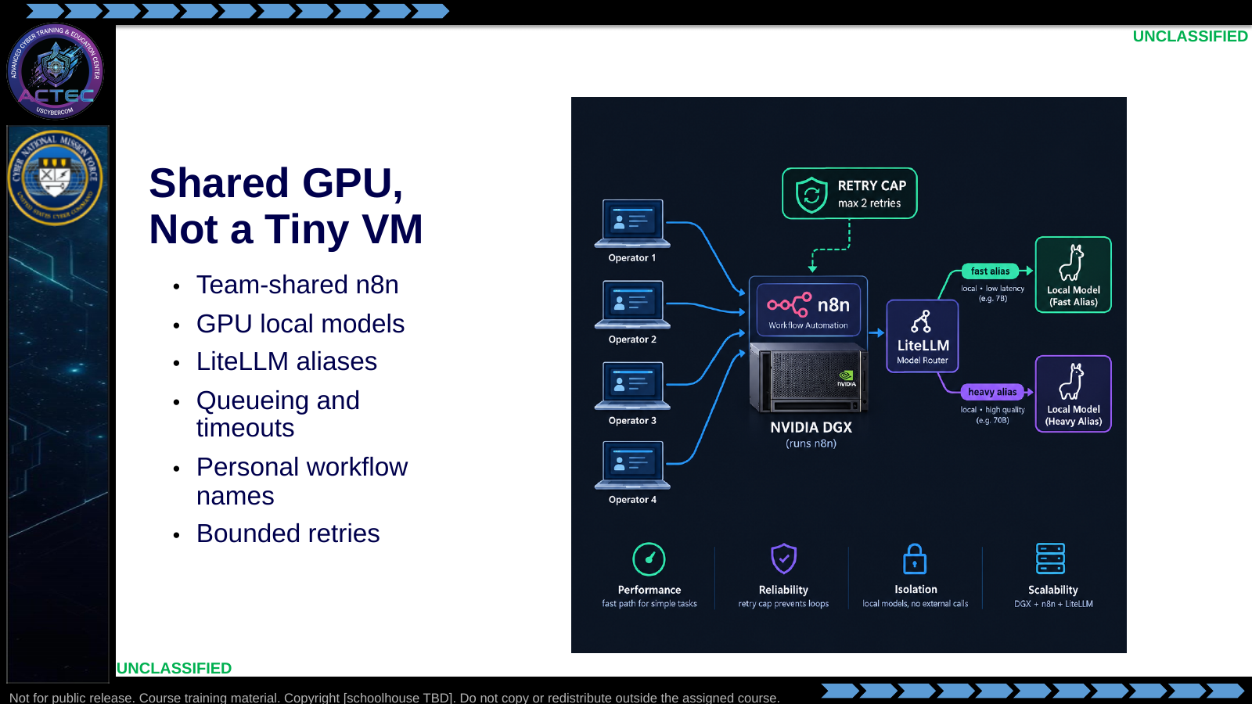  Slide 16: Shared GPU, Not a Tiny VM  Duration: 4 min | Say: "You are not on a 16 GB CPU VM. You are on a shared Spark. GPU is faster, but concurrent class use still needs timeouts, retries, and the lighter alias for bulk extract. Name workflows with your last name so grading does not collide."  Show: Secondary alias for IP extract, primary for triage, retry cap from the afternoon lab.  Do: Ask what fails first if every team hits the heavy alias at once.  Ask (Q): What is the operational takeaway from this row?  Expected Response (A): Facilitation. Restate the Say/Do in operator terms. Do not invent a new teaching point.
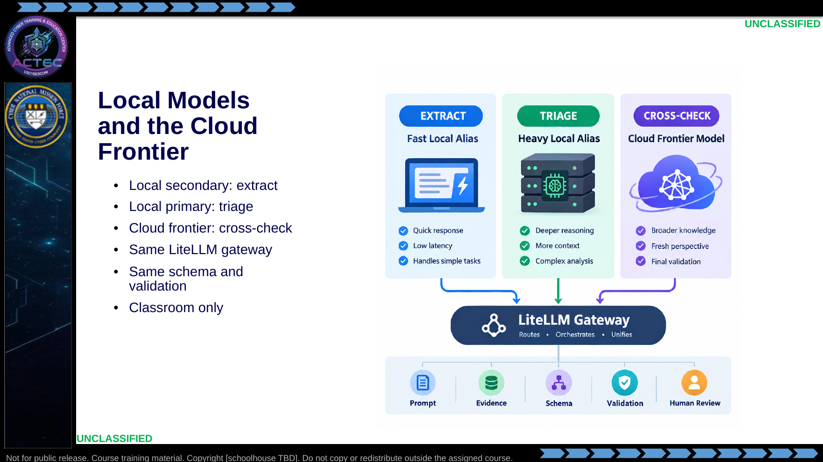  Slide 17: Local Models and the Cloud Frontier  Duration: 4 min | Say: "Morning uses two local models through LiteLLM. Afternoon adds a cloud frontier model on the second branch. The gateway is the same; the trust boundary is not. Keep the schema, validation, and human-review flag when the model changes."  Show: Extract vs triage vs frontier-branch reinforcement. CTI summaries also use a local alias on the instructor host — students only see the API.  Do: Ask what must stay unchanged when the model changes. Expected: evidence boundaries, prompt structure, output schema, validation, audit, human review.  Ask (Q): What is the operational takeaway from this row?  Expected Response (A): Facilitation. Restate the Say/Do in operator terms. Do not invent a new teaching point.

4.3 Lesson summary
- B04.M12-build-agentic-workflow is executed as a generated lesson plan from this file.
- Assessment methods live on module.yaml; do not invent extra official ELOs.
- Later practice in this Block continues from the product this session collects.

4.4 Questions and check on learning
- Ask (Q): What is the operational takeaway from this row?
- Expected Response (A): Facilitation. Restate the Say/Do in operator terms. Do not invent a new teaching point.
- Ask (Q): Which of these should stay deterministic: blocking a hash from a vetted feed, or summarizing an ambiguous process tree?
- Expected Response (A): Facilitation. Use the Say/Do already on this row; do not force a single keyed answer.
- Ask (Q): What is the operational takeaway from this row?
- Expected Response (A): Facilitation. Restate the Say/Do in operator terms. Do not invent a new teaching point.

5. Classification
Classification: UNCLASSIFIED

